**Indexs**

Answer 1:

create clustered index idx_1

on Operation.MemberSessions (MemberId,LoginDateTime)

with FILLFACTOR = 80

Answer 2:

select *

from [Operation].[MemberSessions]

where id like '1234%' and year(LoginDateTime)= '2010'

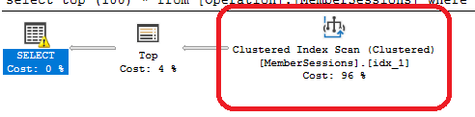

Answer 3:

select *

from [Operation].[MemberSessions] ms join [Operation].[Members] m

on ms.MemberId = m.Id

join [Lists].[Genders] g

on m.GenderId = g.Id

join [Lists].[MaritalStatuses]mars

on m.MaritalStatusId = mars.Id

where g.Id = '2' and mars.Id = '1' and (year(getdate())-year(m.BirthDate)=25)  
order by ms.MemberId, ms.LoginDateTime

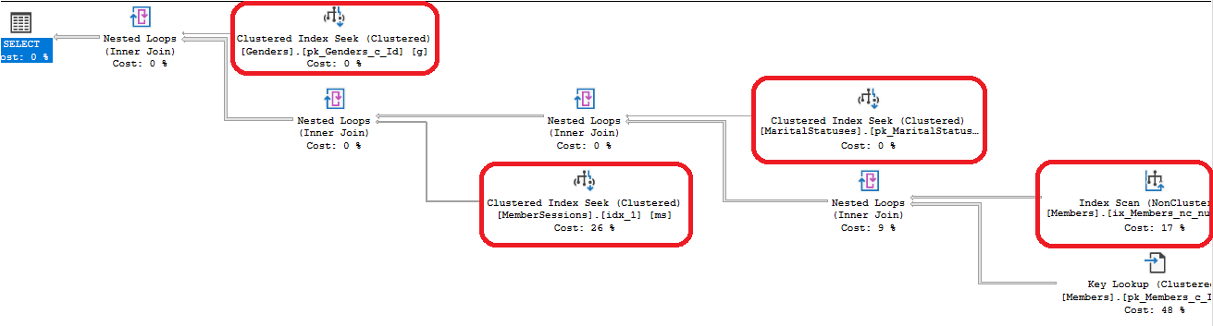

Answer 4:

create unique nonclustered index idx_2

on [Operation].[Members] (Username,password)

Answer 5:

select *

from [Operation].[Members]

where [Username]='xxxx' and Password='12345'  
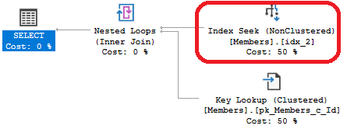

Answer 6:

insert into [Operation].[Members] ([Username],[Password],[FirstName],[LastName],

[CountryId],[EmailAddress],[GenderId],[BirthDate],[RegistrationDateTime])

values ('yogi',1234,'yogev','cohen',1,'yogev@gmail,com',1,'11-09-1986',getdate())

insert into [Operation].[Members] ([Username],[Password],[FirstName],[LastName],

[CountryId],[EmailAddress],[GenderId],[BirthDate],[RegistrationDateTime])

values ('yogi',1234,'tal','cohen',2,'tal@gmail,com',2,'01-06-1989',getdate())  
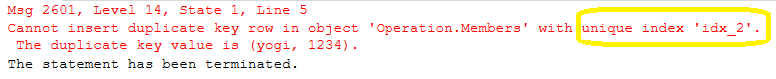

Answer 7:

DBCC SHOW_STATISTICS ("[Operation].[Members]",[CountryId])  


Answer 8:

create nonclustered index idx_3

on [Operation].[Members] ([FirstName],[LastName])

where [FirstName]='paul' and [LastName]='simon'

select oi.RequestingSessionId

from [Operation].[Members] om join [Operation].[Invitations] oi

on om.Id = oi.ReceivingMemberId

where om.FirstName='paul' and om.LastName='simon'

Answer 9:

create nonclustered index idx_4

on [Operation].[Invitations] ([Id])

where id >4 and id <9

select *

from [Operation].[Members]

where id not in (5,6,7,8)

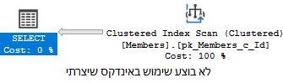

Answer 10:

create nonclustered index idx_5

on [Operation].[Members] (firstname, lastname)

where lastname like 'B%'

select firstname, lastname

from [Operation].[Members]

where lastname like 'B%'

Answer 11:

select firstname, lastname

from [Operation].[Members]

where lastname like '%B'

Answer 13:

select birthdate

from [Operation].[Members]

where StreetAddress is null and (year(getdate())-year(birthdate))>50

create nonclustered index idx_6

on[Operation].[Members] (birthdate)

where StreetAddress is null

Answer 14:

create UNIQUE clustered index idx_7

on [Operation].[Members] (id)

with FILLFACTOR = 100

ON [PRIMARY]

Answer 15:

create nonclustered index idx_8

on [Operation].[MemberSessions] (EndDateTime,EndReasonId)

INCLUDE (MemberId)

with FILLFACTOR = 100

ON [PRIMARY]

Answer 17:

create nonclustered index idx_9

on [Operation].[Members] (Id,CountryId)

create nonclustered index idx_10

on [Operation].[MemberSessions] (MemberId,LoginDateTime)

Answer 18:

select name,type_desc , is_unique,fill_factor

from sys.indexesS

Answer 19:

CREATE STATISTICS [countryID] ON [Operation].[Members]([CountryId])

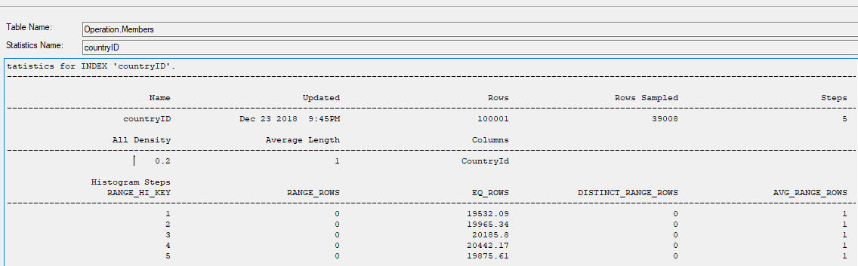

Answer 20:

create table checkfillfactor (

column_1 varchar (100))

declare @i int = 0

while (@i<1000)

begin

insert into checkfillfactor

values (@i)

set @i = @i + 1

end

create nonclustered index idx_11

on [dbo].[checkfillfactor] (column_1)

with fillfactor = 80

create nonclustered index idx_12

on [dbo].[checkfillfactor] (column_1)

with fillfactor = 10

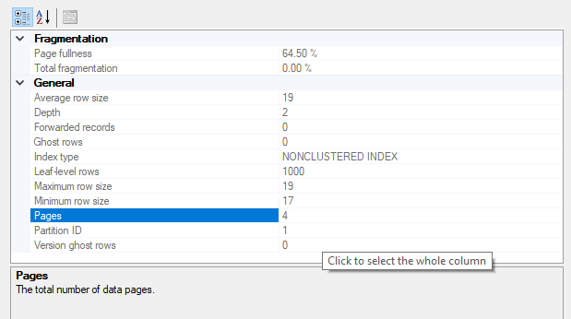

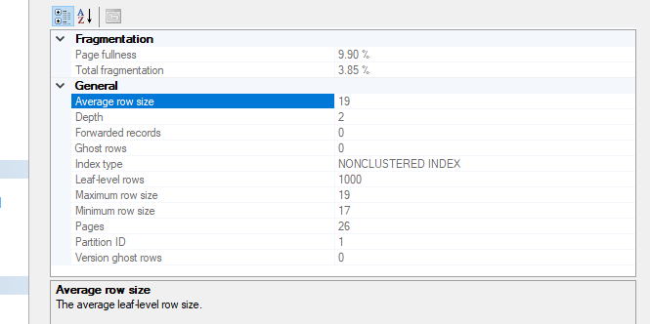

Answer 22:

select name, type_desc, is_unique,fill_factor

from sys.indexes

Answer 23:

create table comp_1(

A char (10),

comp as (A A) persisted)

declare @i int = 0

while (@i < 10000)

begin

insert into comp_1

values (@i)

set @i = @i +1

end

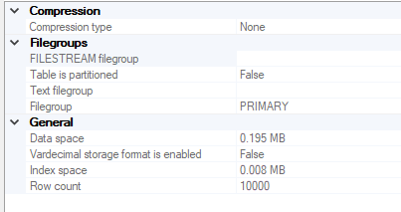

create table comp_2(

A char (10),

comp as (A A) persisted)

declare @i int = 0

while (@i < 10000)

begin

insert into comp_2

values (@i)

set @i = @i +1

end

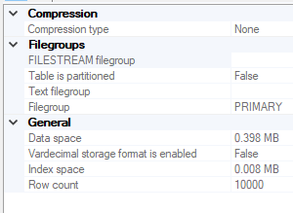

Answer 24:

A - Yes

B – No

Answer 28: